Scope of Works Current Floor Plan
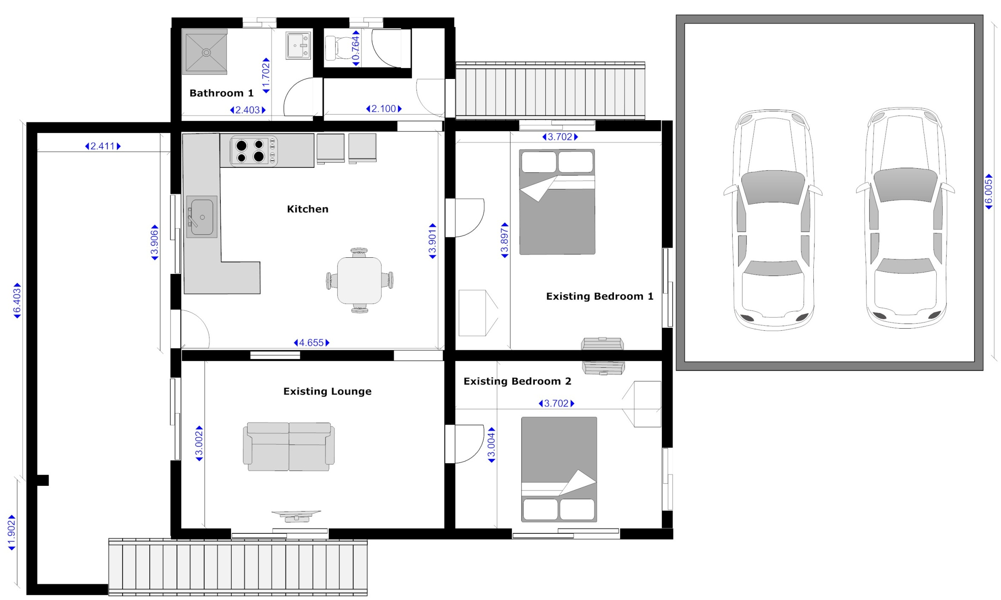

Scope of Works New Floor Plan
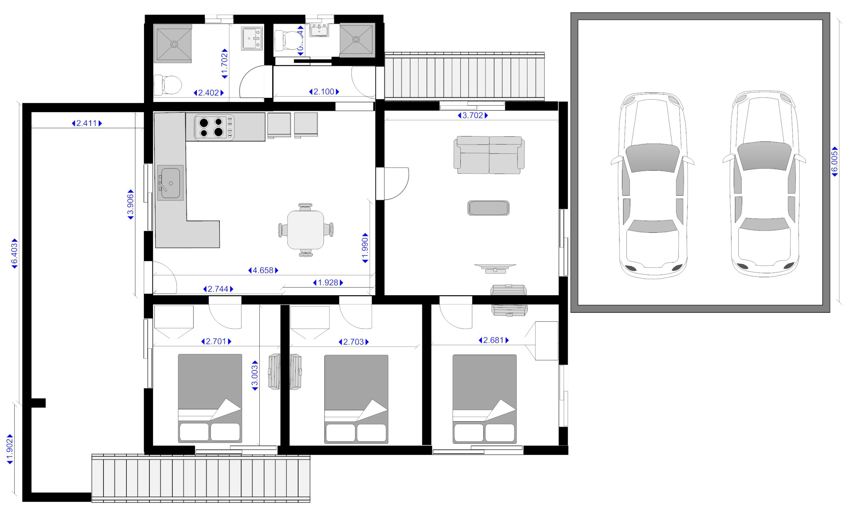

Material List

 | Room | Task | Materials | Supplied by trade | Supplied by owner
CARPENTER | Create two new walls | Create new walls up to the roof line. | Villa Board (not recessed edge)
CARPENTER | Create two new walls | Create new walls up to the roof line. | Architraves
CARPENTER | Create two new walls | Create new walls up to the roof line. | Skirting boards
CARPENTER | Create two new walls | Create new walls up to the roof line. | Cornice beading (quad)
CARPENTER | Bedroom 1  Internal door | Install new internal door for bedroom 1 | New internal door
CARPENTER | Bedroom 1  Internal door | Install new internal door for bedroom 1 | Door handle with entrance lock (matching keys for all internal doors)
CARPENTER | Bedroom 1  Internal door | Install new internal door for bedroom 1 | Hinges
CARPENTER | Bedroom 1  Internal door | Install new internal door for bedroom 1 | Door Jam set
CARPENTER | Bedroom 2  Internal door | Install new internal door for bedroom 2 | New internal door
CARPENTER | Bedroom 2  Internal door | Install new internal door for bedroom 2 | Door handle with entrance lock (matching keys for all internal doors)
CARPENTER | Bedroom 2  Internal door | Install new internal door for bedroom 2 | Hinges
CARPENTER | Bedroom 3  Internal door | Install new internal door for bedroom 3 | New internal door
CARPENTER | Bedroom 3  Internal door | Install new internal door for bedroom 3 | Door handle with entrance lock (matching keys for all internal doors)
CARPENTER | Bedroom 3  Internal door | Install new internal door for bedroom 3 | Hinges
CARPENTER | Bedroom 3  Internal door | Install new internal door for bedroom 3 | Door Jam set
CARPENTER | Bathroom 1 | Replace shower basin with moulded shower. | Fully moulded shower with central soap holder, corner waste outlet.
CARPENTER | Bathroom 1 | Replace shower basin with moulded shower. | Shower head (only to be purchased if current fitting insufficient)
CARPENTER | Bathroom2 | Install new moulded shower in conjunction with plumber | Fully moulded shower with central soap holder, corner waste outlet.
CARPENTER | Bathroom2 | Install new moulded shower in conjunction with plumber | Shower Head
CARPENTER | Bathroom2 | Install new moulded shower in conjunction with plumber | Mixer Tap
CARPENTER | Bathroom2 | Install new moulded shower in conjunction with plumber | Shower curtain
CARPENTER | Bathroom2 | Construct wall around shower | Villa Board (not depressed edge)
CARPENTER | Bathroom2 | Construct wall around shower | Architraves
CARPENTER | Bathroom2 | Construct wall around shower | Skirting boards
CARPENTER | Bathroom2 | Construct wall around shower | Cornice beading (quad)
CARPENTER | Bathroom2 | Install external cavity sliding door for access to bathroom 2. | External sliding door
CARPENTER | Bathroom2 |  | Door handle
CARPENTER | Bathroom2 |  | Pelmet
CARPENTER | Back door entrance | Replace back door | External door
CARPENTER | Back door entrance | Replace back door | Door handle with entrance lock to match internal doors
CARPENTER | Back door entrance | Replace back door | Hinges
CARPENTER | Back door entrance | Replace back door | New Door Jams  (maybe optional)

 | Room | Task | Materials | Supplied by trade | Supplied by owner
ELECTRICIAN | Bedroom 1 | Install P1 | Double power point
ELECTRICIAN | Bedroom 1 | Install A1 | Aerial Point
ELECTRICIAN | Bedroom 1 | Install P2 | Double power point
ELECTRICIAN | Bedroom 1 | Install A\C P1 | Single Power Point
ELECTRICIAN | Bedroom 1 | Install/move L1 | Single Light switch  (maybe optional as existing fitting can be reused)
ELECTRICIAN | Bedroom 1 | Install/move L1 | Light Fitting  (maybe optional as existing fitting can be reused)
ELECTRICIAN | Bedroom 2 | Install P4 | Double power point
ELECTRICIAN | Bedroom 2 | Install A2 | Aerial Point
ELECTRICIAN | Bedroom 2 | Install P3 | Double power point
ELECTRICIAN | Bedroom 2 | Install P5 | Double power point
ELECTRICIAN | Bedroom 2 | Install A\C P2 | Single Power Point
ELECTRICIAN | Bedroom 2 | Install/move L2 | Single Light switch
ELECTRICIAN | Bedroom 2 | Install/move L2 | Light Fitting
ELECTRICIAN | Bedroom 3 | Install P7 | Double power point
ELECTRICIAN | Bedroom 3 | Install A3 | Aerial Point
ELECTRICIAN | Bedroom 3 | Install P6 | Double power point
ELECTRICIAN | Bedroom 3 | Install A\C P3 | This is an existing power supply which may need to be moved.
ELECTRICIAN | Bedroom 3 | Install/move L1  See note for bedroom 1 | Single Light switch  (maybe optional as existing fitting can be reused)
ELECTRICIAN | Bedroom 3 | Install/move L1  See note for bedroom 1 | Light Fitting  (maybe optional as existing fitting can be reused)
ELECTRICIAN | Lounge | Install P8 | Double power point
ELECTRICIAN | Lounge | Install A2 | Aerial Point
ELECTRICIAN | Lounge | Install A\C P4 | This is an existing power supply which may need to be moved.
ELECTRICIAN | Bathroom 2 | Install P9 | Double power point
ELECTRICIAN | Bathroom 2 | Install/move L4 Existing floor plan has a light fitting in this room which may need to be moved. | Single Light switch
ELECTRICIAN | Bathroom 2 |  | Install light fittings in roof (where required)
ELECTRICIAN | External Back Door Sensor lights | Move SS1 | Existing light switch available
ELECTRICIAN | External Back Door Sensor lights | Upgrade S1 | Single globe sensor light.
ELECTRICIAN | External Front Door Sensor lights | Check SS2 | Existing light switch available
ELECTRICIAN | External Front Door Sensor lights | Upgrade S2 | Double globe sensor light.

 | Room | Task | Materials | Supplied by trade | Supplied by owner
AIR CON | Bedroom 1 | Install Air Conditioner Unit | Air Conditioner Unit | To be agreed
AIR CON | Bedroom 1 | Install Condenser | Ait Conditioner Condenser
AIR CON | Bedroom 2 | Install Air Conditioner Unit | Air Conditioner Unit | To be agreed
AIR CON | Bedroom 2 | Install Condenser | Ait Conditioner Condenser

 | Room | Task | Materials | Supplied by trade | Supplied by owner
PLUMBER | Bathroom 1 | Install toilet next to shower | New toilet including cistern
PLUMBER | Bathroom 1 | Connect toilet to sewer and water | To be supplied by plumber
PLUMBER | Bathroom 1 | Connect replaced shower to existing drainage/water/plumbing. | To be supplied by plumber
PLUMBER | Bathroom 2 | Install hand basin | Hand basin
PLUMBER | Bathroom 2 | Connect hand basin to drainage/ water/plumbing | To be supplied by plumber
PLUMBER | Bathroom 2 | Connect new shower to existing drainage/ water /plumbing. | To be supplied by plumber

 | Room | Task | Materials | Supplied by trade | Supplied by owner
MAINTENANCE | Bathroom 1 | Install toilet roll holder | Toilet roll holder
MAINTENANCE | Bathroom 1 | Move hand rail | Existing hand rail to be used
MAINTENANCE | Bathroom 2 | Install mirror/cabinet | Mirror/cabinet
MAINTENANCE | Bathroom 2 | Install Shower rail | Shower Rail
MAINTENANCE | Bathroom 2 | Install Towel Hook | Install Towel Hook
MAINTENANCE | General | Replace deck railings | Treated pine | To be agreed
MAINTENANCE | General | Insert flashing | flashing | To be agreed
MAINTENANCE | General | Secure down pipes on house | Downpipe bracket, or possibly cable ties
MAINTENANCE | General | Paint anti rust on all posts under house (2 coats) | Anti-rust paint
MAINTENANCE | General | Seal roof end caps with water tight sealant | sealant
MAINTENANCE | General | Seal any bathroom areas | sealant
MAINTENANCE | General | Glue and Seal kitchen tiles | sealant
MAINTENANCE | General | Rear stair rail | Treated pine | To be agreed
MAINTENANCE | General | Paint all renovated areas of house | Paint  Painting equipment

Carpenter

Trade | Room | Task | Materials
Carpenter | Existing Bedroom 2 | Remove non-structural wall and door from existing lounge leading to existing  Bedroom 2. Currently This wall does not reach the ceiling.

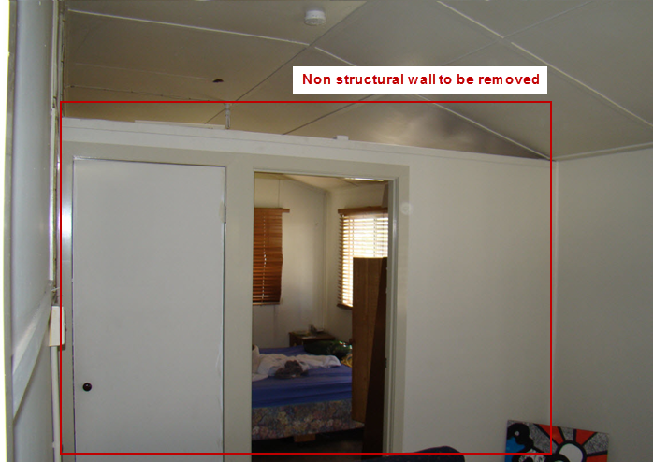
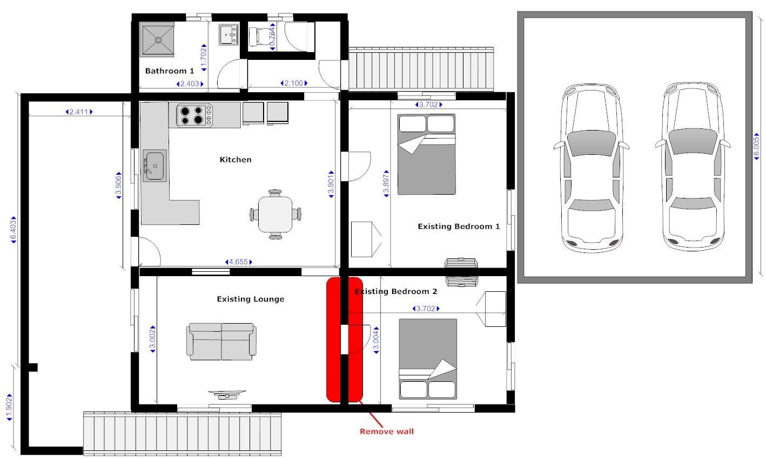

Trade | Room | Task | Materials
Carpenter | Create two new walls | Create new walls up to the roof line.  Note: Walls will require wiring for power points. | Villa Board (not recessed edge)  Architraves  Skirting boards  Cornice beading (quad)
Carpenter | Bedroom 1  Internal door | Install new internal door for bedroom 1  Note: existing wall has a servery window which might be able to be used for doorway. If not this space needs to be filled in. | New internal door  Door handle with entrance lock (matching keys for all internal doors)  Hinges  Door Jam set
Carpenter | Bedroom 2  Internal door | Install new internal door for bedroom 2  Note: the existing hallway door could be used for this door frame. | New internal door  Door handle with entrance lock (matching keys for all internal doors)  Hinges
Carpenter | Bedroom 3  Internal door | Install new internal door for bedroom 3.  Note: This door had a servery window which has been filled in. It could be used for the doorway. It has an A/C powerpoint which may need to be moved. | New internal door  Door handle with entrance lock (matching keys for all internal doors)  Hinges  Door Jam set

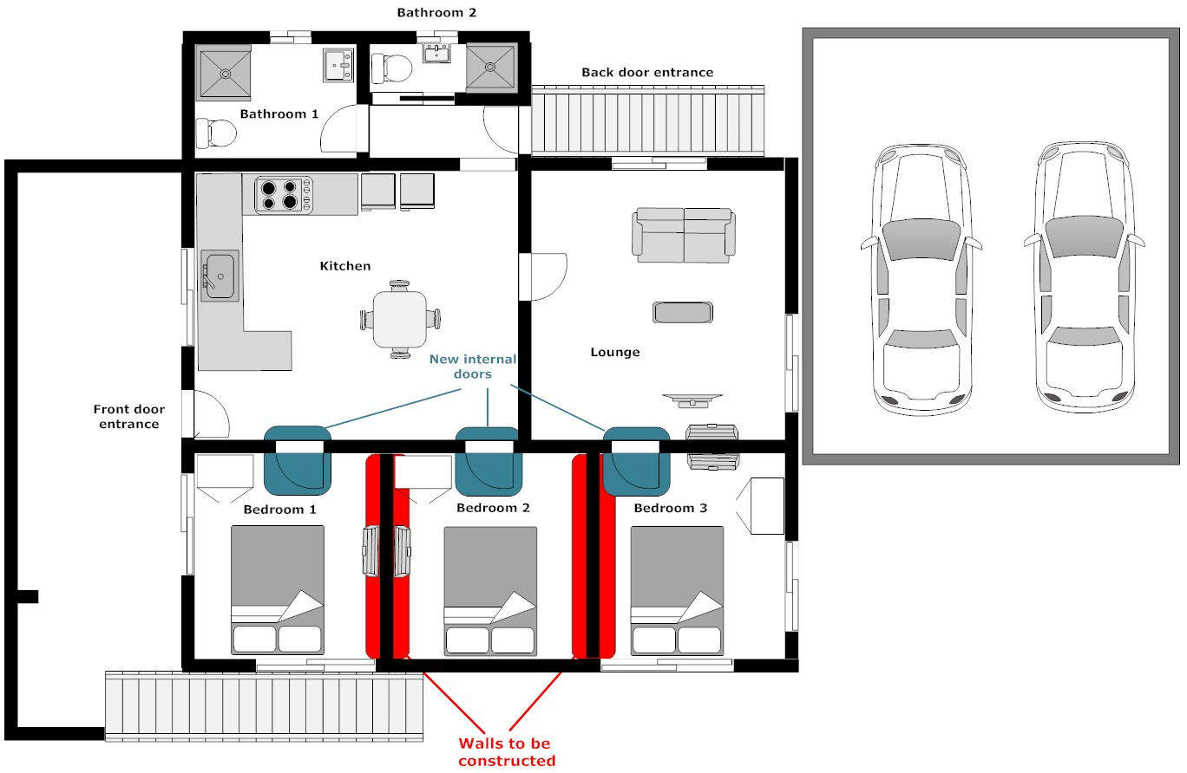

Existing servery window
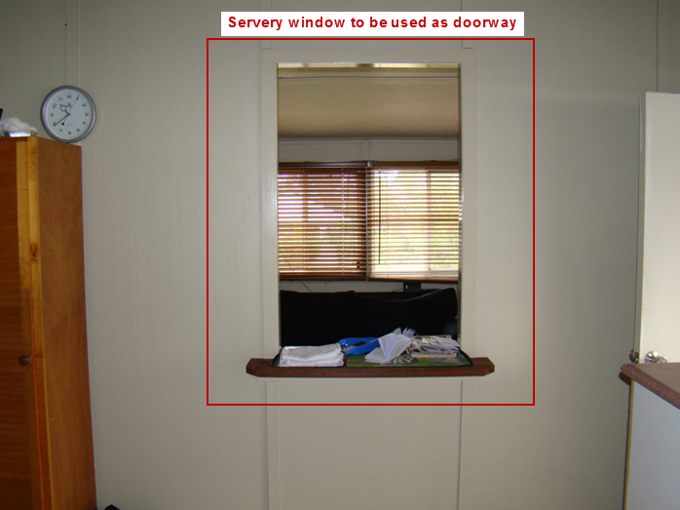

Front door entrance with servery window (same as above, photo from different angle)
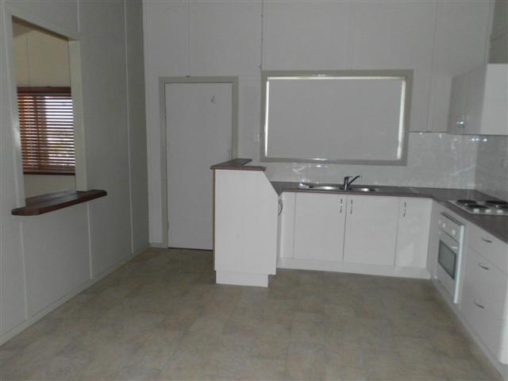
Photo taken inside kitchen, viewing servery window and existing hallway door. The servery window will be doorway for bedroom 1 and the hallway door will be the doorway for bedroom 2.
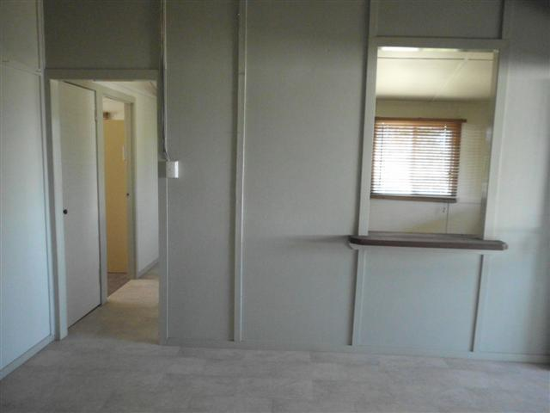

Photo taken inside existing lounge room, looking through servery window into the kitchen. This room is to be converted into bedroom1 and bedroom 2.
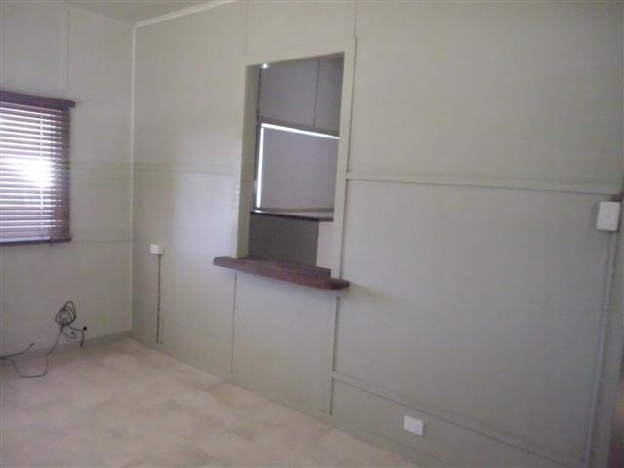
Trade | Room | Task | Materials
Carpenter | Bathroom 1 | Replace shower basin with moulded shower.  Note: In conjunction with plumber | Fully moulded shower with central soap holder, corner waste outlet.  Note: Two sides will be fibreglass, with remaining sides being glass.  Tap fittings (use existing), Leave bath taps as well for bucket filling.  Shower head (use existing if part is in decent condition, otherwise new unit)

Floor Plan
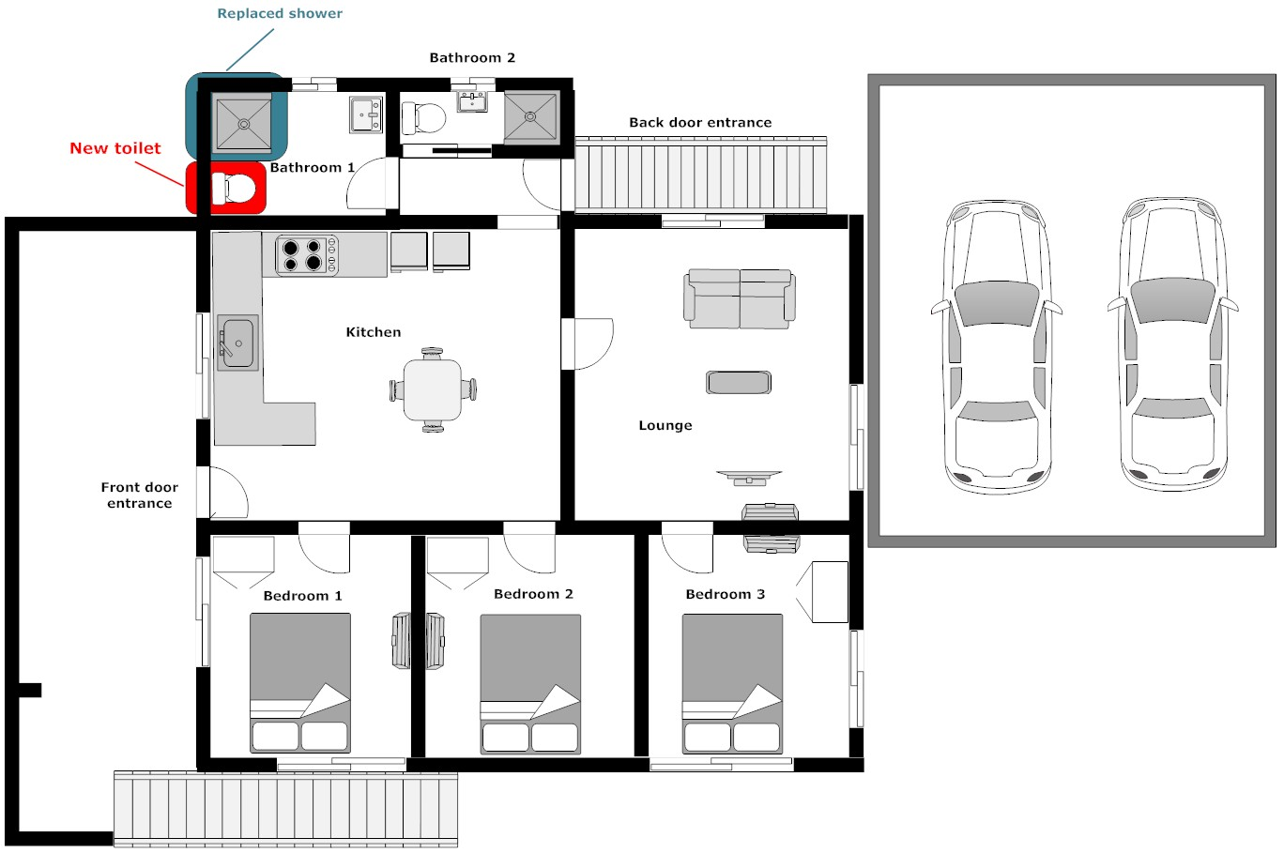

Existing shower in bathroom 1
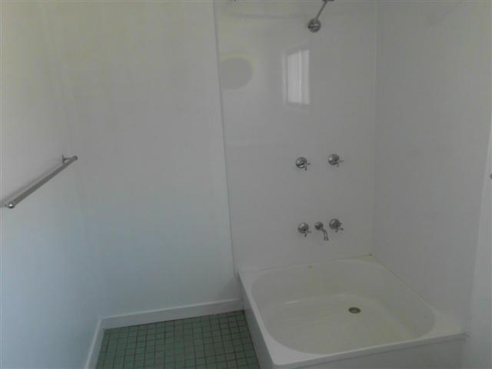
Trade | Room | Task | Materials
Carpenter | Bathroom 2 | Remove existing toilet door.
Carpenter | Bathroom2 | Install new moulded shower in conjunction with plumber | Fully moulded shower with central soap holder, corner waste outlet.  Shower Head  Mixer Tap  Shower curtain  Note: Three sides will be fibreglass, with remaining side open with shower rail.
Carpenter | Bathroom2 | Construct wall around shower | Villa Board (not depressed edge)  Architraves  Skirting boards  Cornice beading (quad)
Carpenter | Bathroom2 | Install external cavity sliding door for access to bathroom 2.  Note: This wall does not currently have a doorway installed. | External sliding door  Door handle  Pelmet

New Bathroom layout
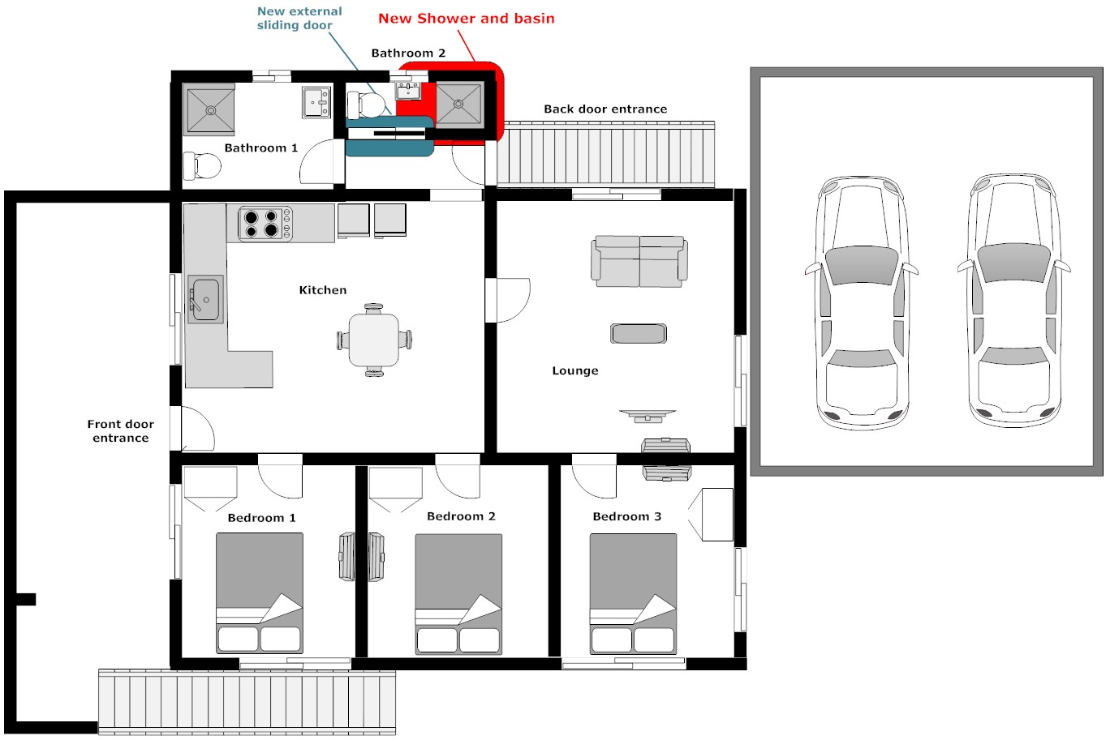
Position in house
Trade | Room | Task | Materials
Carpenter | Back door entrance | Replace back door  Note: back door may need to be resized due to installation of shower, unsure of size at this point. | External door  Door handle with entrance lock to match internal doors  Hinges  New Door Jams (maybe optional)

Rear door entrance
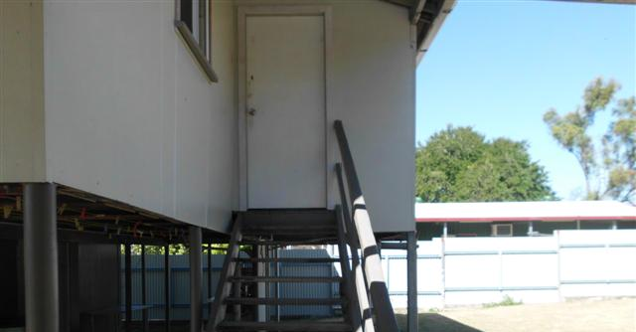

Rear door looking from inside bathroom 1
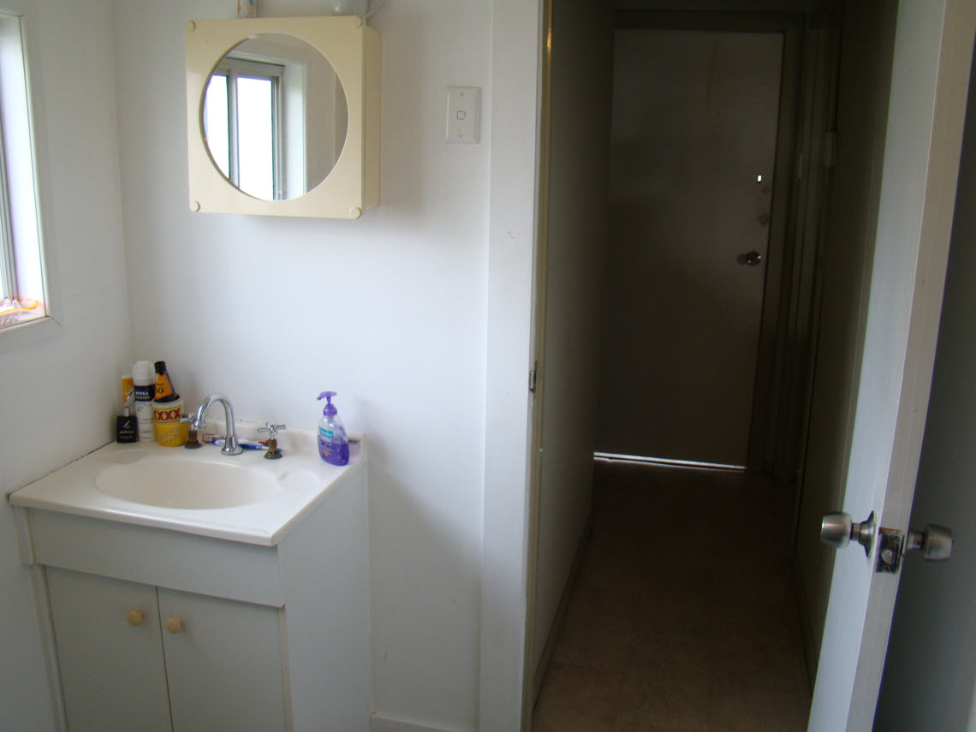

Plumber

Trade | Room | Task | Materials
Plumber | Bathroom 1 | Install toilet next to shower | New toilet including cistern. Supplied by owner
Plumber | Bathroom 1 | Connect toilet to sewer and water | To be supplied by plumber
Plumber | Bathroom 1 | Connect replaced shower to existing drainage/ water /plumbing. | To be supplied by plumber

Bathroom layout

Position in house
Trade | Room | Task | Materials
Plumber | Bathroom 2 | Install hand basin | Hand basin supplied by owner
Plumber | Bathroom 2 | Connect hand basin to drainage/ water/plumbing | To be supplied by plumber
Plumber | Bathroom 2 | Connect new shower to existing drainage/ water /plumbing. | To be supplied by plumber

New Bathroom layout

Position in house

Electrician

Summary of electrical work
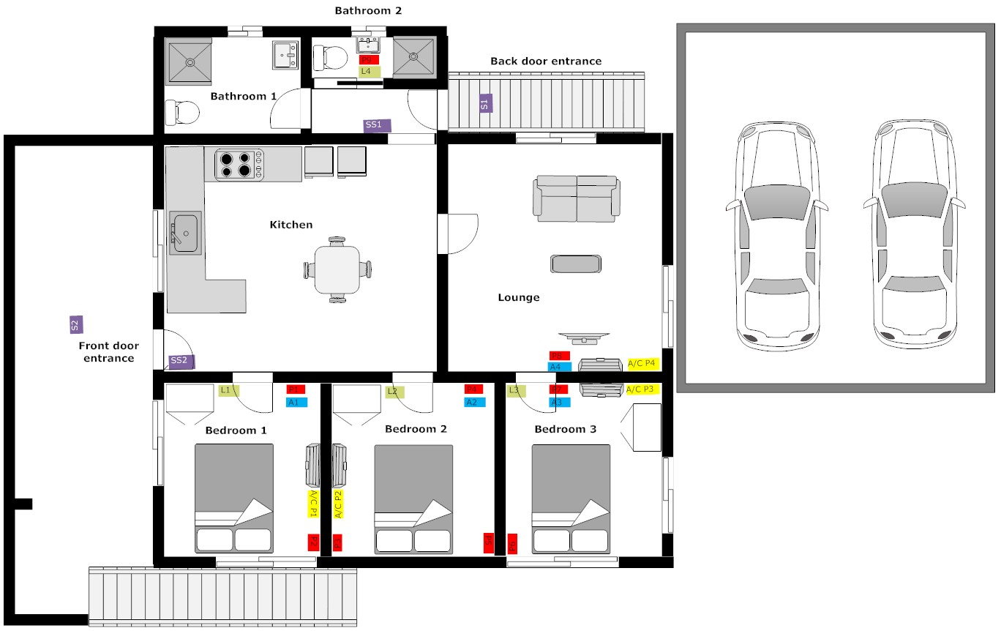

Trade | Room | Task | Materials
Electrician | Bedroom 1 | Install P1 | Double power point
Electrician | Bedroom 1 | Install A1 | Aerial Point
Electrician | Bedroom 1 | Install P2 | Double power point
Electrician | Bedroom 1 | Install A\C P1 | Single Power Point
Electrician | Bedroom 1 | Install/move L1  Note: Existing floor plan has two light fittings across the bedrooms, these will need to be replaced/shifted to have lights in each room. | Single Light switch  Install light fittings in roof (where required)
Electrician | Bedroom 2 | Install P4 | Double power point
Electrician | Bedroom 2 | Install A2 | Aerial Point
Electrician | Bedroom 2 | Install P3 | Double power point
Electrician | Bedroom 2 | Install P5 | Double power point
Electrician | Bedroom 2 | Install A\C P2 | Single Power Point
Electrician | Bedroom 2 | Install/move L2  See note for bedroom 1 | Single Light switch  Install light fittings in roof (where required)
Electrician | Bedroom 3 | Install P7 | Double power point
Electrician | Bedroom 3 | Install A3 | Aerial Point
Electrician | Bedroom 3 | Install P6 | Double power point
Electrician | Bedroom 3 | Install A\C P3  Note: This is an existing power supply which may need to be moved.
Electrician | Bedroom 3 | Install/move L1  See note for bedroom 1 | Single Light switch  Install light fittings in roof (where required)

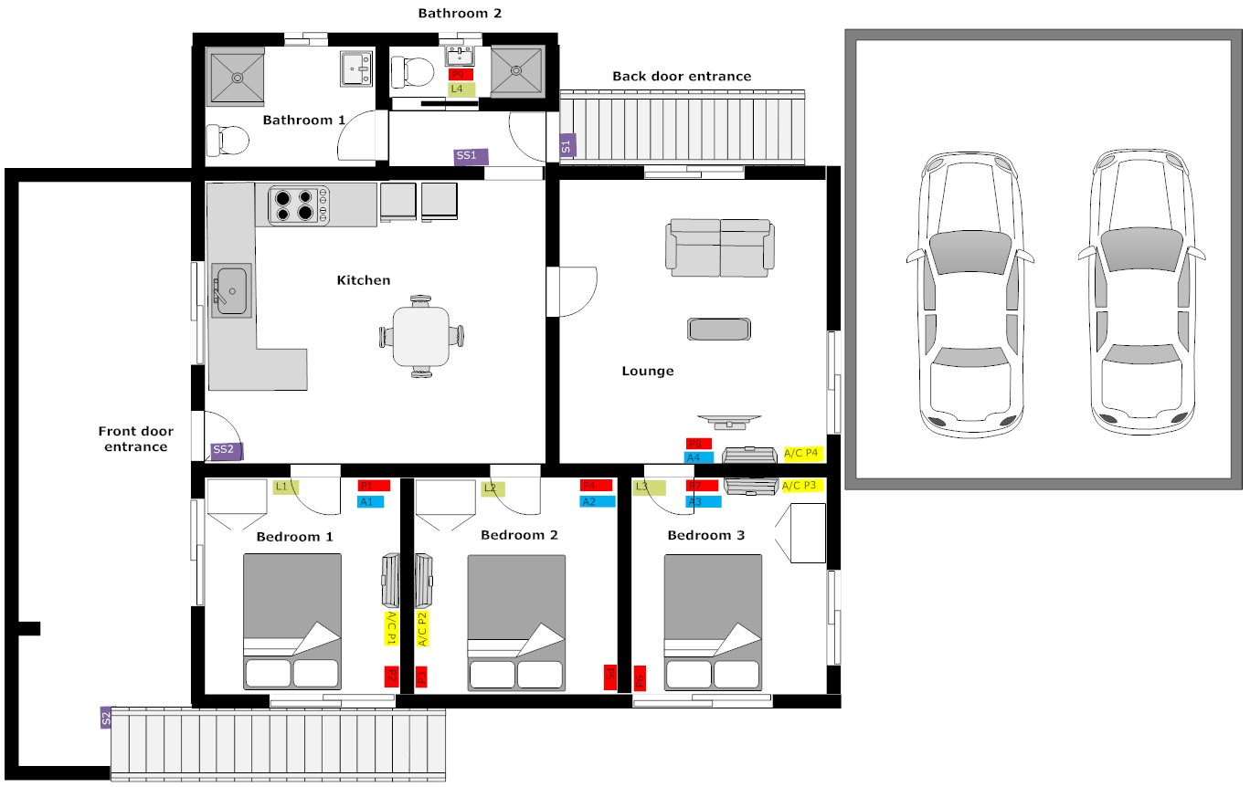

Trade | Room | Task | Materials
Electrician | Lounge | Install P8 | Double power point
Electrician | Lounge | Install A2 | Aerial Point
Electrician | Lounge | Install A\C P4  Note: This is an existing power supply which may need to be moved.

Trade | Room | Task | Materials
Electrician | Bathroom 2 | Install P9 | Double power point
Electrician | Bathroom 2 | Install/move L4  Note: Existing floor plan has a light fitting in this room which may need to be moved. | Single Light switch  Install light fittings in roof (where required)

Trade | Room | Task | Materials
Electrician | External Back Door Sensor lights | Move SS1  Note: This may be required due to the bathroom 1 renovation. If light switch in a good position, no change required. | Optional (see note) Single light switch controlling external sensor light (double switch can be used if existing fitting available and this is a better option)
Electrician | External Back Door Sensor lights | Upgrade S1  Note: existing light fitting, refer to photos below | Upgrade existing light fitting to a single globe sensor light.

Floor Plan

Location of existing light fitting

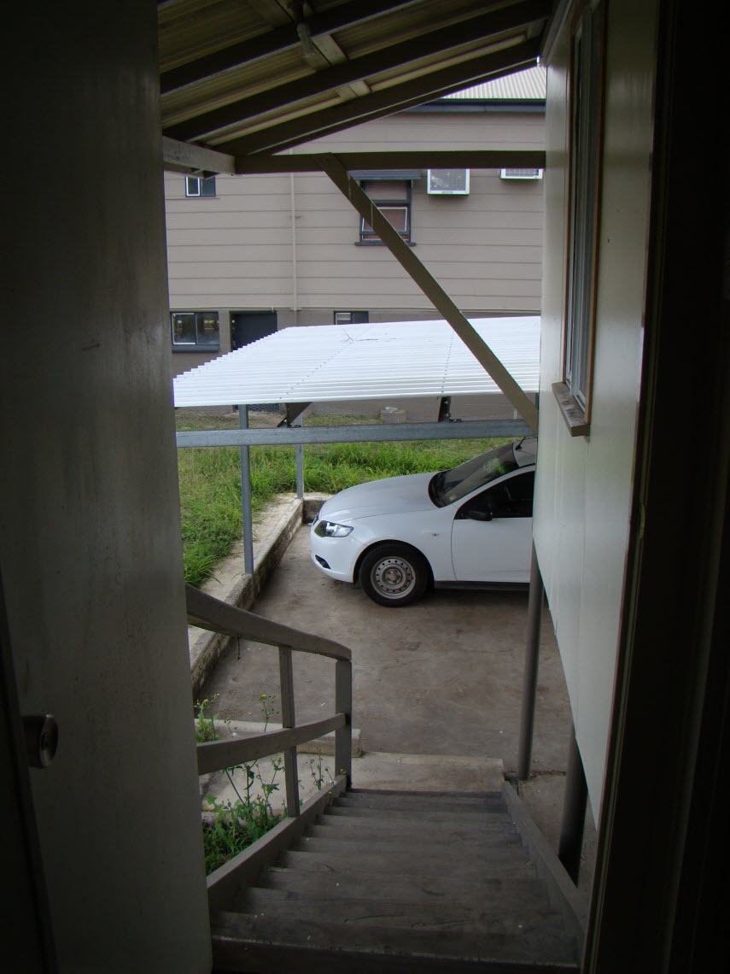
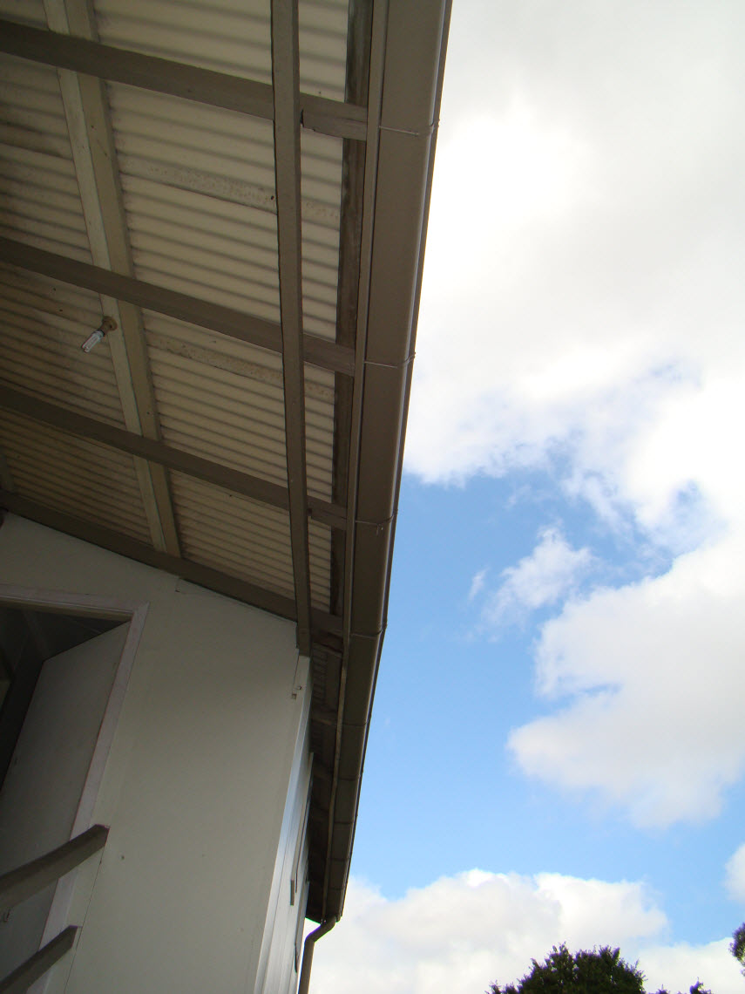

Trade | Room | Task | Materials
Electrician | External Front Door Sensor lights | Check SS2  Note: Do not expect any changes for this light switch | If changes needed:  Single light switch controlling external sensor light (double switch can be used if existing fitting available and this is a better option)
Electrician | External Front Door Sensor lights | Upgrade S2  Note: existing light fitting, refer to photos below | Upgrade existing light fitting to a double globe sensor light.  First light pointing to front door entrance, second light pointing along deck.

Floor Plan

Location of existing light fitting
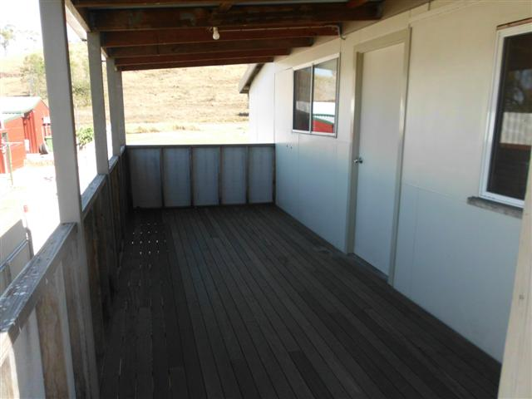

Air Conditioner

Trade | Room | Task | Materials
Electrician or Air Con Specialist | Bedroom 1 | Install Air Conditioner Unit | To be supplied by tradesman or owner
Electrician or Air Con Specialist | Bedroom 1 | Condenser | Position of condenser may need to run through the storage room downstairs and then out to the highset area of the house. Storage room does not have a ceiling.  Note: Need positioning to consider location of outdoor setting under the house.
Electrician or Air Con Specialist | Bedroom 2 | Install Air Conditioner Unit | To be supplied by tradesman or owner
Electrician or Air Con Specialist | Bedroom 2 | Condenser | See notes above.

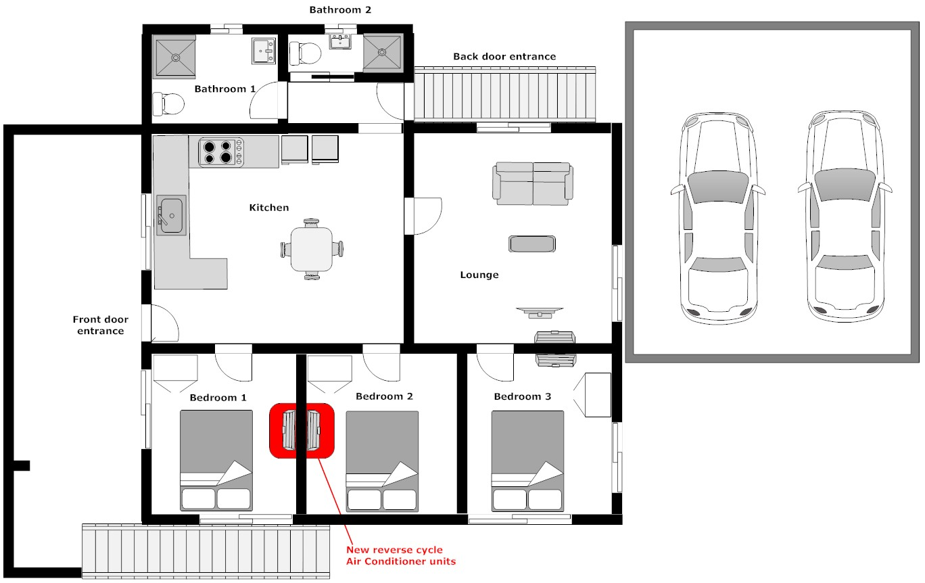

General Maintenance

Trade | Room | Task | Materials | Responsible Party
Maintenance | Bathroom 1 | Install toilet roll holder | Toilet roll holder | Owner
Maintenance | Bathroom 1 | Move hand rail |  | Owner
Maintenance | Bathroom 2 | Install mirror/cabinet | Mirror/cabinet | Owner
Maintenance | Bathroom 2 | Install Shower rail | Shower Rail | Owner
Maintenance | Bathroom 2 | Install Towel Hook | Install Towel Hook | Owner
Maintenance | General | Replace deck railings with treated pine timber (or alternate materials to make up to standard) | Treated pine | Owner with assistance from carpenter
Maintenance | General | Insert flashing above deck roof near front door | flashing | Owner with assistance from carpenter
Maintenance | General | Secure down pipes on house | Downpipe bracket, or possibly cable ties | Owner
Maintenance | General | Unblock and clean down pipes at front of house |  | Owner
Maintenance | General | Check down pipes at base where water might run onto the slab - divert away (digging a trenches and placing a pit may be required) |  | Owner
Maintenance | General | Paint anti rust on all posts under house (2 coats) | Anti-rust paint | Owner
Maintenance | General | Seal roof end caps with water tight sealant | sealant | Owner
Maintenance | General | Seal any bathroom areas with water tight sealant | sealant | Owner
Maintenance | General | Glue and Seal kitchen tiles that might be loose due to movement | sealant | Owner
Maintenance | General | Rear stair rail need to be repaired or replaced as it's not up to code | Treated pine | Owner with assistance from carpenter
Maintenance | Paint | Paint all renovated areas of house including  - Bedroom 1  - Bedroom 2  - Bedroom 3  - Bathroom 2 | Paint | Owner

