

Insert Trading Trust Logo (if applicable)
Email
Phone
E |
W |
P |
M |

Investor Report

Address:

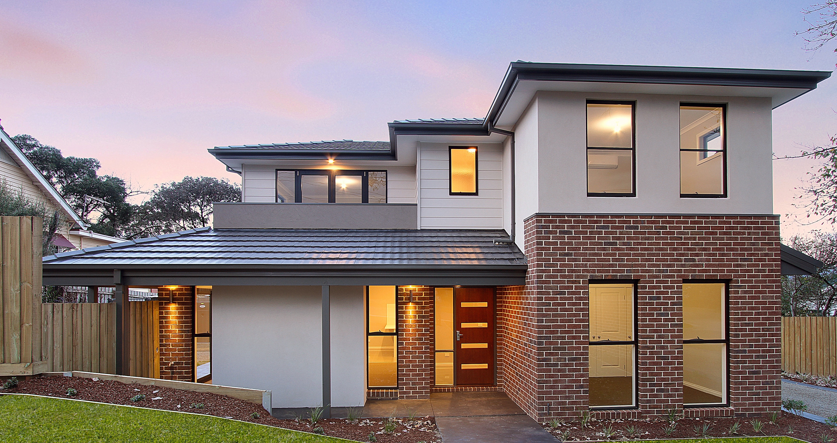

Prepared By:
Insert name
Insert Trading Details
ABN

Write two or three paragraphs summarising this document.

<Insert signature>
<Insert name>

<INSERT PHOTO>

Contents
PROPOSAL | 3
LOCATION | 4
PHOTOS | 5
FINANCIAL FEASIBILITY | 5
CASH FLOW ANALYSIS | 6
CAPITAL REQUIREMENTS | 7
SUBURB PROFILE | 8
COMPARABLE SALES DATA | 10
PLANNING INFORMATION | 13
TESTIMONIALS | 16
WHO ARE YOU? | 16
CONTACT | 20


Proposal

- In this section summarise the deal / proposal. This is an opportunity to use dot points explaining the deal and the overall benefits.

Location

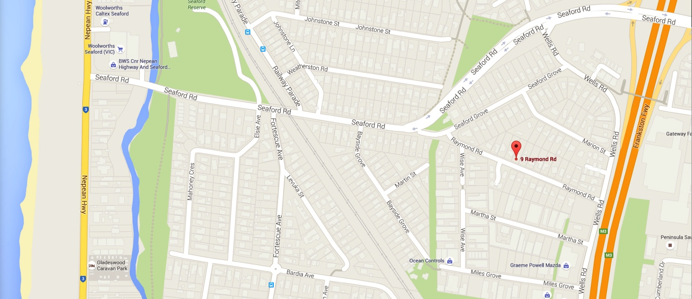

OVERVIEW

Include a brief description of the suburb.
Station : 1.4 KM

Freeway Access: 0.7 KM

Shopping Centre: 0.9 KM

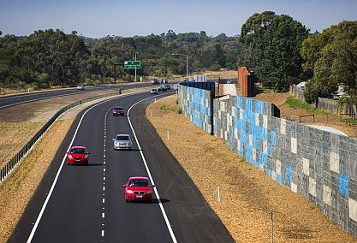

Photos

<INSERT PHOTOS OF THE PROPERTY & THE AREA>

Feasibility Report
<Insert full snap shot of feasibility study (one page)>

Cash Flow Analysis
UPON COMPLETION – HOLD
 | Operations | Rooms | Vacancy Contingency | P/Week Revenue | P/Annum Revenue
 |  |  |  | $ | $
 |  |  |  | $ | $
 |  |  |  | $ | $
 |  |  |  | $ | $
 |  |  |  | $ | $
 |  |  |  | $ | $
 |  |  |  | $ | $
 |  |  |  | $ | $
 |  |  |  | $ | $
TOTAL REVENUE |  |  |  | $ | $

OUTGOINGS
Interest on Loan | $ | $
Insurances | $ | $
Bills | $ | $
General Maintenance | $ | $
Council Rates | $ | $
Land Tax | $ | $
Gardener | $ | $
Wireless Internet | $ | $
Management Fees | $ | $
TOTAL OUTGOINGS | $ | $
Total Cash flows | $ | $

Capital Requirements

Capital Required - Time Line
Month | Description/Stage | Amount
April ‘16 |  | $
May ‘16 |  | $
June ‘16 |  | $
July ‘16 |  | $
August ‘16 |  | $
September ‘16 |  | $
October ‘16 |  | $
November ‘16 |  | $
December ‘16 |  | $
January ‘17 |  | $
February ‘17 |  | $
March ‘17 |  | $
April ‘17 |  | $
May ‘17 |  | $
June ‘17 |  | $
July ‘17 |  | $
TOTAL CASH REQUIRED |  | $240,072.00

Suburb Profile

<INSERT SUBURB PROFILE DETAILS & GRAPHS>

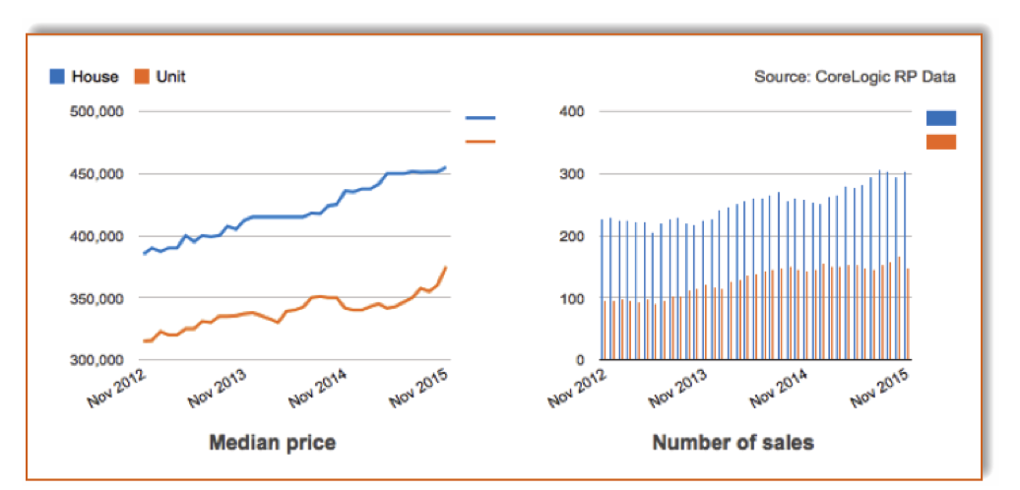
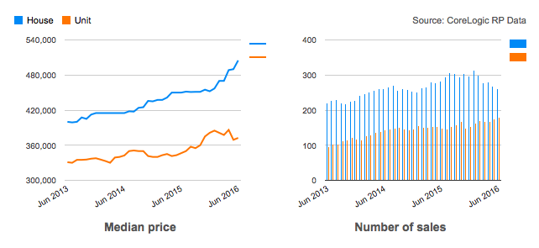

 | HOUSE | UNIT
Median price | $505,000 | $372,500
Quarterly growth | 6.09% | -1.32%
12-month growth | 11.91% | 6.43%
Average Annual Growth | 7.24% | 5.27%
Weekly median advertised rent | $360 | $300
Number of sales | 260 | 179
Gross rental yield | 3.71% | 4.19%
Day on market | 38.34 | 56.19

Insert relevant information here regarding the Suburb, profile statistics, demographics, infrastructure, and anything else unique.

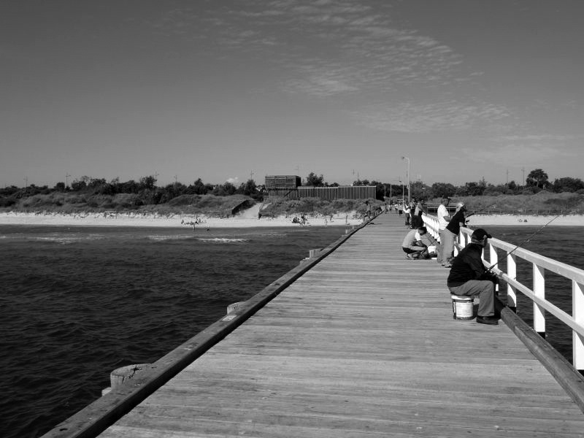

AUCTION CLEARENCE
75%
DAYS ON MARKET
38
MARKET DATA
THREE BEDROOM HOUSE IN S………

SOLD THIS YEAR
260
MEDIAN HOUSE
$505K

*Source: data collected from Corelogic RP Data magazine

Comparable Sales Data

Planning Information

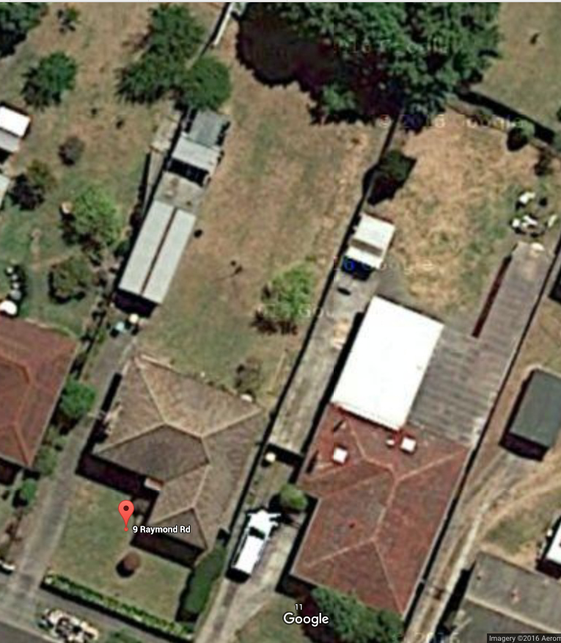

Planning scheme data last updated on 14 January 2016.
A planning scheme sets out polices and requirements for the use, development and protection of land.
This report provided information about the zones ad overlay provisions that apply to the selected land.
Information about the State, local particular and general provisions of the local planning scheme that may affect the use of this land can be obtained by contacting the local council or by visiting the Planning Schemes Online.
This report is NOT a Planning Certificate Issued pursuant to Section 199 of the Planning & Environment Act 1987.
It does not include information about exhibited planning scheme amendments, or zoning that may abut the land.
To obtain a Planning Certificate go to the Titles and Property Certificates
For details of surrounding properties, use the service to get the Reports for properties of Interest
To view planning zones, overlay and heritage information in and Interactive format visit Planning Maps Online
For other information about planning in Victoria visit www.delwp.vic.gov.au/planning
Planning Zones

Planning Overlays

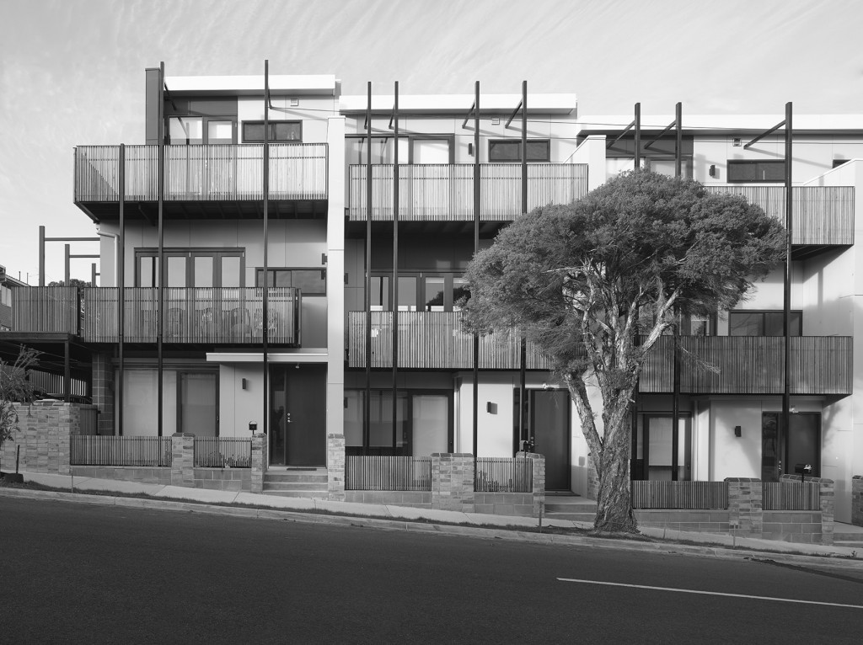
Testimonials


<NAME>
<TITLE>
<Insert testimonial here>
CONGRUENCY

I’m ready for the next one!

<Your name>
Your Title and/or Trading Name
<Insert a description of yourself, achievements and experience.

<INSERT A PHOTO OF YOURSELF>



P |
M |

PHONE
Address |

ADDRESS
THANK YOU FOR
YOUR BUSINESS


EMAIL
E |
W |

