SUMMARY
Trade | Task Summary | Notes
Ian Wassell House Removals | Stumping scheduled for completion by 30th April 2014  Need copy of: Building Contract, BSA Licences, Public Liability Insurance & Indemnity Certificate of Currency | Entire Building Re-Stumped
Demolition & Asbestos Removal | Removal of Internal Lining: (Inc. all asbestos), 2 kitchens, internal doors, fireplace, laundry / bathroom fixtures as per details outlined in section 1.  Items to be Kept for Reuse: Selected fixtures, fittings & appliances to be kept for reuse as per details outlined in section 2. (Separate Demolition Scope Of Works including photos and demolition plans provided) | Upon engagement provide a copy of: BSA & Asbestos Licences, Public Liability Insurance & Indemnity Certificate of Currency
Builder | Provide support to remaining walls following asbestos / lining removal, remove any remaining walls as per plans and build new walls, install internal & external doors, assemble bathrooms, co-ordinate all trades, kitchen & appliance installation, floor covering, install weathertex external cladding, verandah handrail, new ramp & steps as per details outlined below in section 3 and in according with plans provided & BCA for a class 1b building. | Upon engagement provide necessary BSA Licences, Public Liability Insurance, Indemnity Certificate of Currency and Contract Works Insurance cover for the entire building during renovation  Quote to include QLeave if required = (0.525% of Total Cost of Works)
Plumber | Remove and install new water pipes, sewer & waste pipes, hot water systems, water meter (if required), stormwater to street, section of guttering & 1 downpipe. Install bathroom fixtures as per locations outlined on “Add-A-Bathroom” plan below. (Refer to FP1200 & FP1400 plans)
Electrician | Rewire entire building on 2 separate circuits (as it is currently), oversee upgrade of power (if required), install all electrical fittings as outlined below in section 3 and in according electrical plans & BCA for a class 1b building.

Trade | Subject | Task | Notes
Asbestos Removal & Demolishing Company | All Internal walls of Building | Remove & Dispose of: (Photos & Plans Provided)  - All internal lining to all internal walls, including timber cladding to kitchen ceiling / walls & bathrooms, villaboard lining to bedroom walls & timber cladding to Bed 5 & Bed 5’s Bathroom  - Lining to all ceilings  - Partition-like (non supporting) walls  - Two kitchens including overhead cupboards / shelving  - Hot Water System in kitchen  - Concrete twin laundry tub  - Shelving from pantry room  - Fireplace box / mantle / tiled hearth  - All internal doors & highlights above doors  - Shower bases x 2, Bath, brown timber vanity, shelf unit in bathroom  - Toilets x 2 (pans only to be kept)  Items to be kept: (Photos Provided)  - All vertical posts either side of every doorway  - All corner posts  - All roof support posts – as per plans  - Elba oven – currently in managers kitchen  - White Vanity – currently in managers bathroom area  - 1 built in kitchen sink & mixer tap  - 2 toilet pans  - 1 Panasonic Split System air conditioner with remote – currently in managers living area  - 2 Illuminated exit signs – currently mounted above doorways at front & western side  - 2 oyster lights – currently in proposed bed 9 & bed 9’s bathroom area)  - 2 hardwired smoke alarms – currently in both living areas | Upon engagement provide copy of BSA & Asbestos Licences, Public Liability Insurance & Indemnity Insurance Certificate of Currency
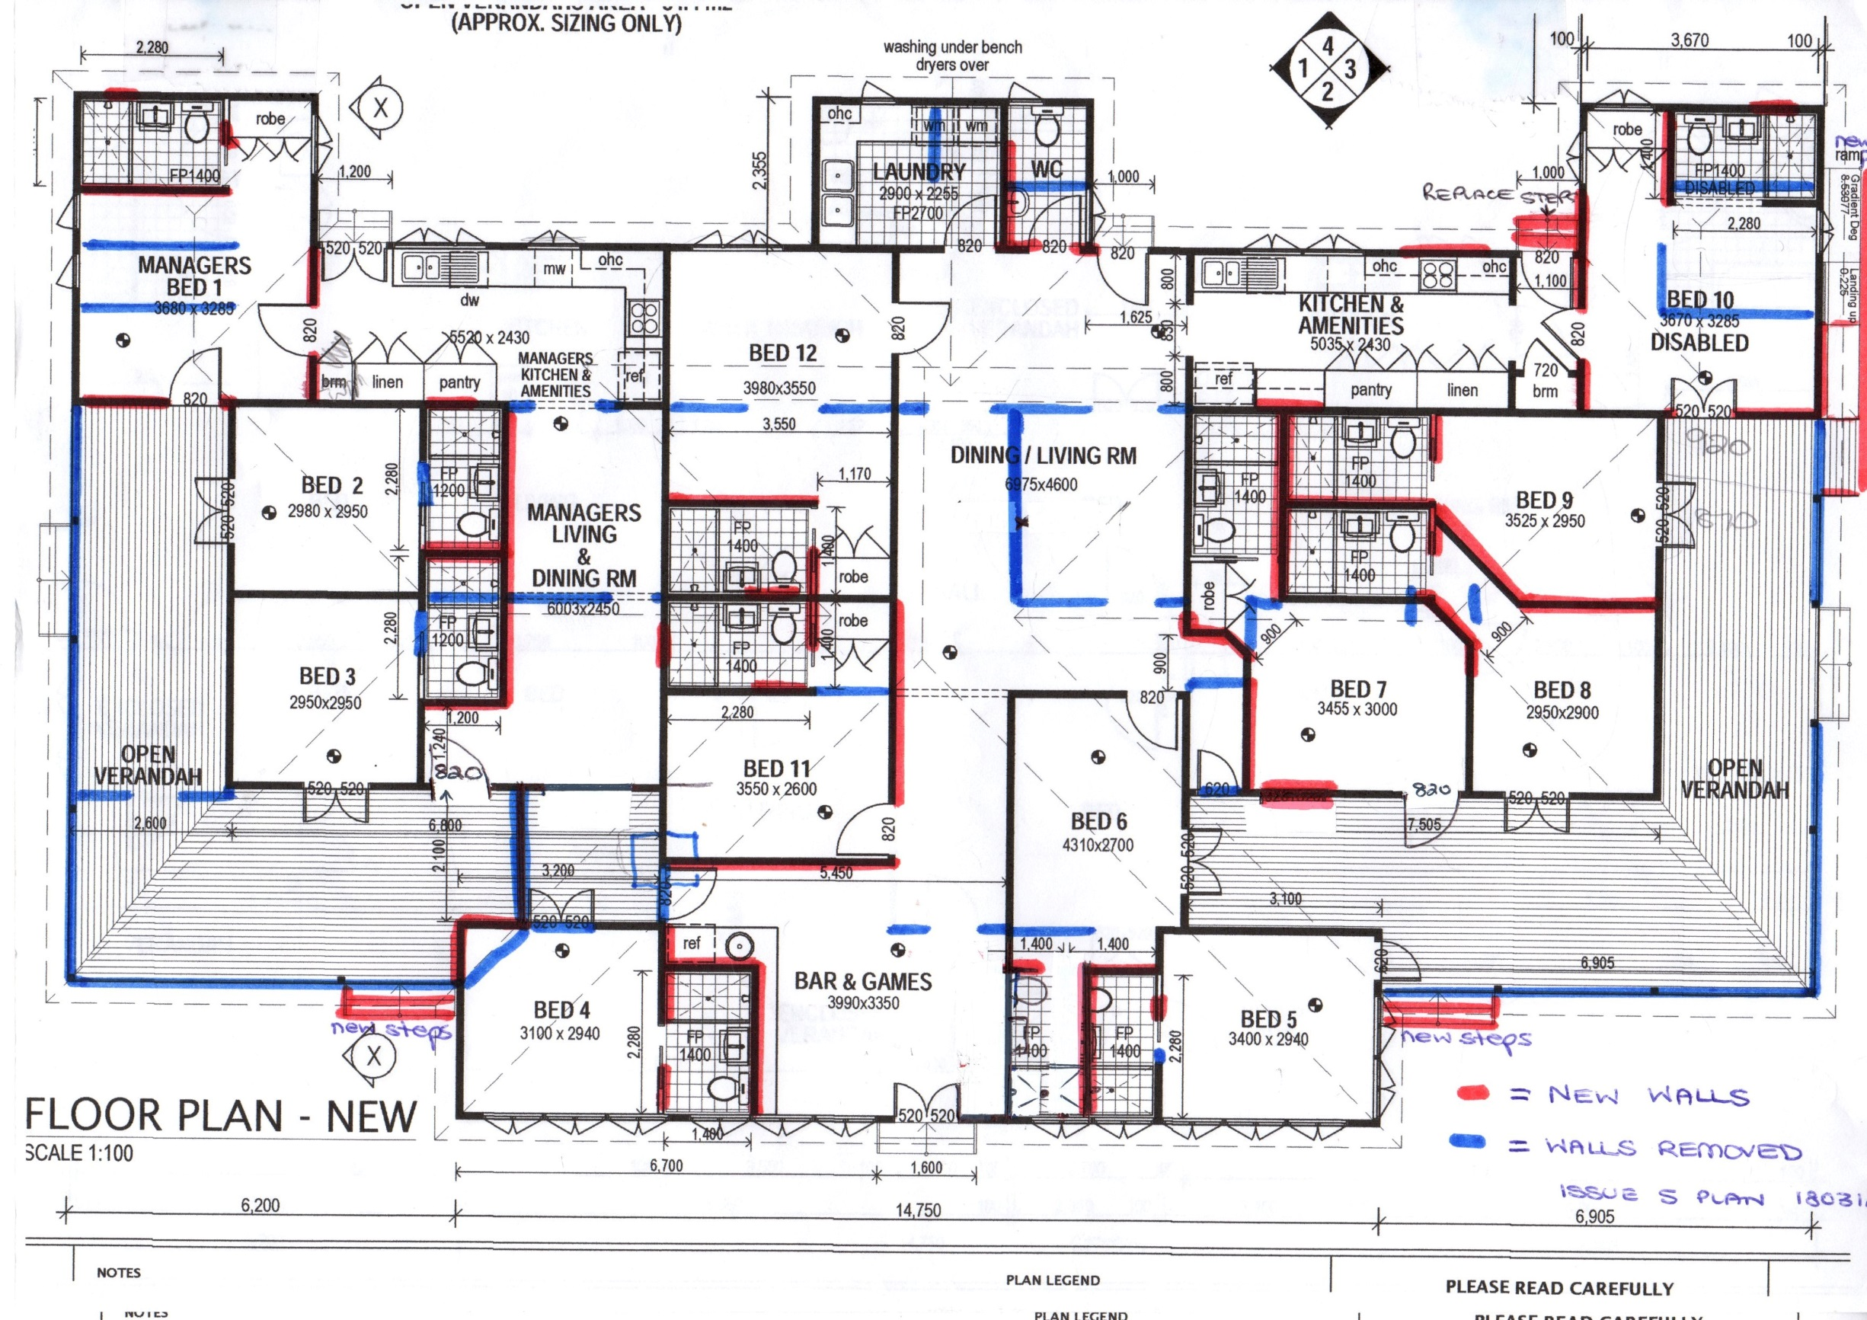
Trade | Subject | Task | Notes
Builder | Carpentry | - Remove any remaining walls, following asbestos removal, as per plans Removal of Existing Walls: Marked on Plan in BLUE; Build New Walls: Marked on Plan in RED.  - Build new 90mm stud walls throughout including necessary bracing as per plans  - Provide support beams as required across Dining / Living & Bed 12  - Maximum ceiling height to be 3mtrs | What cost saving could occur by reducing to 2.7mtr ceilings?
Builder | Internal Lining | - Internal Bedroom Walls to be insulated with R2.5 Insulation Batts - RW40 & RW50 to bathroom walls.  - Internal Bedroom Walls to be Lined with 10mm Plasterboard  - Internal Ceilings to be insulated with R2.5 Insulation Batts  - Internal Ceilings to be lined with 10mm Ceiling Plasterboard  - Skirting Boards = Bullnose minimum 67 x 12mm  - Architraves = Bullnose minimum 67 x 12mm  - Cornice = 90mm Cove Cornice | RW rating of bathroom pods TBC
Builder | Kitchens | - Co-ordinate with Cabinetmaker supply of 2 new laminated kitchens  - Supply & Install 1 new kitchen sink (1.75) & Install existing kitchen sink & existing mixer to Manager’s kitchen  - Supply & Install 1 new oven & install only existing Elba oven to Manager’s Kitchen  - Supply & Install: 2 x Dishwashers, 2 x cooktops, 2 x rangehoods | Separate itemised cost of Builder’s Range to be provided to client for selection
Builder | Bathrooms | - Assemble and install modular bathroom units  - Bathroom Fixtures to be installed as per measurements outlined on FP1200 & FP1400 Add-A-Bathroom plans below  - Bathroom Doors – 11 x Cavity Sliding Doors to fit 705mm doorway opening with lockset  - Build 1388 W x 95mm H ramp for disabled bathroom | Wall to be removed & rebuilt to install bathrooms to bed 5 & 6? & Bed 1?  Client to mark up plan with towel rail & robe hook locations  No door on Bed 10 bathroom  Clayton Wood to confirm details
Builder | Laundry | - Provide cost to tile & line laundry & WC  - Supply & Install: 2 x inbuilt 45L S/Steel laundry trough with 1 shared mixer tap  - Supply & Install: 2 x sets washing machine tap  - Co-ordinate with Cabinetmaker new benchtop & small overhead cupboard as per plan | As cost comparison vs purchasing modular units
Builder | Bar & Games | - Co-ordinate with Cabinetmaker new bar benchtop  - Supply & install small sink & mixer
Builder | Doors | - Internal Bedroom Doors – 5 x Flush Standard with key locksets  - Internal Laundry / WC Doors – 2 x Flush Standard (lock to WC)  - External Bedroom / Entrance Doors – 15 x 820mm wide & 1 x 620mm with level handle keylock sets  - External Security Screen Doors with Door Closer – 15 x 820mm opening & 1 x 620mm opening  - What would extra cost be to have 1 master key to all locks? | CLIENT TO CONFIRM STYLE  CLIENT TO CONFIRM STYLE
Builder | Painting | - Painting – Internal house ceilings & walls (Excluding all bathrooms)  - Laundry & WC TBC – may use modular units  - Verandah ceilings  - Stain Merbau Decking
Builder | Flooring | - Raise floor of lean-to section of Bedroom 12 & Main Dining at rear to same height as internal floor with 18mm compressed yellow tongue compressed sheet flooring  - Floor Coverings - Commercial grade timber look-a-like vinyl to all rooms except bathrooms / (laundry & WC – TBC) | TBC if modular bathrooms units used for laundry & wc  NEED TO DETERMINE HEIGHT OF THESE ROOMS
Builder | Robes & Cupboard | - Supply & install 5 x in-built sliding door robes, with shelves & hanging rail to bedrooms 1, 7, 10, 11 & 12  - Supply & install inbuilt cupboard to hallway between kitchen & bed 10 | Provide separate cost
Builder | Fire Extinguishers | - Provide & Install Fire Extinguishers within 4mtrs of an exit to each kitchen & bar area: 3 x 4.5kg dry powder type; 3 x 9ltr water type & 3 x fire blankets
Builder | Windows | - Remove 3 existing aluminium windows from western verandah and install in Bedroom 4, Games & Bedroom 5 (Sizes 2210W x 1130H; 2995W x 1130H; 2975W x 1130H)  - Supply & install new 1800W x 900H window to Main Kitchen, allowing for small splashback above sink  - Supply & install new 1500W x 900H window to Manager’s Kitchen, allowing for small splashback above sink  - Supply & install new 1200W x 1200H window to Manager’s Bedroom | Builder to check window measurements  Builder to check new window measurements  CLIENT TO CONFIRM IF REQUIRED
Builder | Exterior | - Remove and enclose old windows that are not required with weathertex or hardi plank?  - Verandah Ceilings to be lined with 10mm Plasterboard (in line with rafters)  - Verandah exterior walls to be removed to floor level and single timber handrail installed  - Clad internal verandah walls with Weathertex cladding, to match existing weatherboards  - Eastern Verandah – Replace decking with Merbau Reeded 90 x 19mm Stained  - Western Verandah - Replace decking with Merbau Reeded 90 x 19mm Stained  - External Steps – Provide 2 new hardwood tread steps (with side stringers) to front verandah & replace 2 existing weather-damaged set of steps outside main kitchen at rear | Kylie to specify  Separate cost for this please  CLIENT TO CONFIRM STYLE  Eastern decking needs replacing  Provide separate price for Western decking (not essential to replace at this stage)
Builder | Rubbish Removal | - Removal all builders / trade rubbish

Additional Costs
QLeave = 0.525% of Total Cost of Works
BSA Insurance
Contract Work Insurance

Trade | Task | Notes
Plumber | Replace Earthenware Waste Pipes with new PVC |  | As Per Hydraulic Services Sanitary Plan 1812131-H-100-PR-A
Plumber | Replace Existing Water Pipes with new |  | As Per Hydraulic Services Water Plan 1812131-D-200-PR-A
Plumber | Install 2 x 613/315 Rheem (45amps) Hot Water Cylinders with Equa-Flow Manifold 3 x 3.6KW Elements and Install Rheem Hot Water Pump Set 890666 |  | As Per Hydraulic Services Water Plan 1812131-D-200-PR-A
Plumber | New Water Meter Required? |  | Obtain costing from council
Plumber | Replace section of damaged guttering on Eastern Side of Building with existing style (Lysaght?)  Move downpipe outlet on eastern side to allow for new proposed disabled access ramp |  | http://www.lysaght.com/product/lysaght-half-round-gutter-and-br-lysaght-flat-back-gutter
Plumber | Stormwater - Run existing downpipes to street |  | Stormwater plan not required as roof area remains unchanged

Trade | Task | Notes
Electrician | Building currently wired on 2 separate circuits – to remain this way.
Electrician | Does power need to be upgraded? If so, cost involved
Electrician | Rewire entire building on 2 separate circuits as per electrical plan. Refer below for detailed list of fittings
Electrician | Smoke Alarms, Emergency Lighting & Illuminated Exit Signs must be linked to function when a smoke alarm is activated
Electrician | TV Aerial – will the 1 existing TV Aerial be sufficient for entire building? | Refer to photo below
Electrician | Internet Wifi ? Advice on cost to install and how this would be managed on room by room basis?
Electrician | Foxtel ? | Any extra wiring required for foxtel? Supply cost?
Electrician | Air Conditioning – Quote to be supplied for most cost effective system | TBC - Ducted vs Split vs Wall Mounted

Electrical Summary
Quantity | Item | Supplied By Builder | Supplied By Owner
47 | Low Voltage Down Lights | 47
14 | Light / Fan Units – Refer to photo below for style or similar (Bunnings stock) | 14
66 | Double Power Points | 66
21 | Single Power Points | 21
15 | Ceiling Fans with Lights - Refer to photo below for style or similar (Bunnings stock) | 15
15 | TV Points (mounted 1800mm high in bedrooms) – Existing TV aerial be enough? | 15
15 | Air Conditioners – Quotes to be supplied for Ducted vs Split System | 14 | 1 Existing Panasonic to be reused
12 | External Wall Lights - Refer to photo below for style or similar (Bunnings stock) | 12
2 | Phone Points (separate lines) | 2
16 | Smoke Alarms - Smoke Alarms & Emergency Lighting to be linked together | 14 | 2 Existing to be reused
3 | Emergency Lights | 3
5 | Illuminated Exit Signs | 3 | 2 Existing to be reused
1 | Illuminated Exit Sign with Arrow Pointing towards “T” of exit | 1
232 | TOTAL SUMMARY | 227 | 5

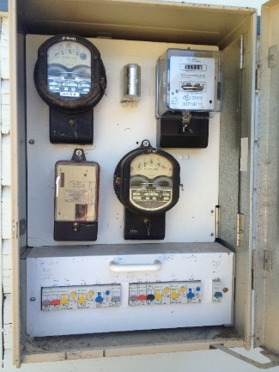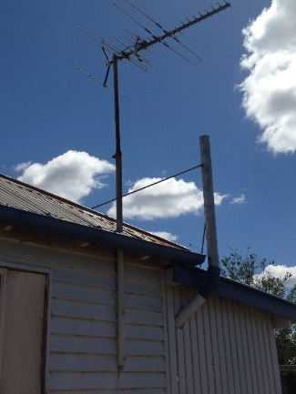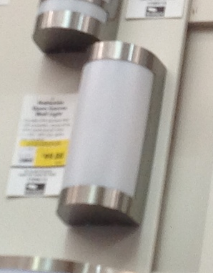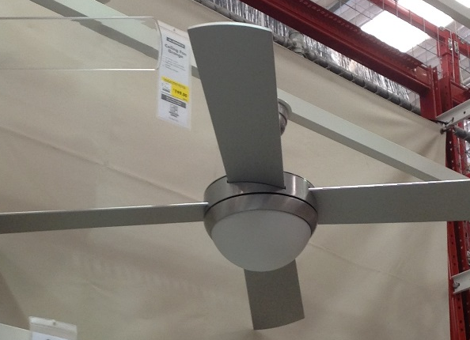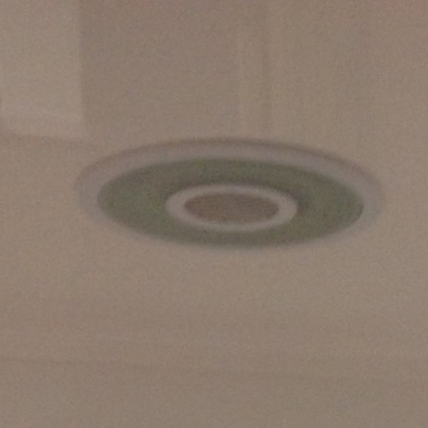
2 separate circuits to remain Existing TV aerial External Wall Light Ceiling Fan with Light Light / Fan Unit

Trade | Proposed Room | Task | Notes
Electrician | Managers Bed 1  Bedroom 7  Bedroom 8  Bedroom 10  Bedroom 11 | QUANTITY PER BEDROOM  - 3 x Low Voltage Down Lights (2 x Bedroom, 1 x Outside Ensuite)  - 1 x Light / Fan in Ensuite  - 4 x Double Power Points  - 1 x Single Power Point (Ensuite)  - 1 x TV Point (mounted 1800mm high with 1 x DPP alongside)  - 1 x Ceiling Fan with Light  - 1 x Air Conditioner  - 1 x Smoke Alarm (linked to main system)
Electrician | Bedroom 2  Bedroom 4  Bedroom 5  Bedroom 6  Bedroom 9 | QUANTITY PER BEDROOM  - 2 x Low Voltage Down Lights  - 1 x Light / Fan in Ensuite  - 4 x Double Power Points  - 1 x Single Power Point (Ensuite)  - 1 x TV Point (mounted 1800mm high with 1 x DPP alongside)  - 1 x Ceiling Fan with Light  - 1 x Air Conditioner  - 1 x Smoke Alarm (linked to main system)
Electrician | Bedroom 3 | - 2 x Low Voltage Down Lights  - 1 x Light / Fan in Ensuite  - 3 x Double Power Points  - 1 x Single Power Point (Ensuite)  - 1 x TV Point (mounted 1800mm high with 1 x DPP alongside)  - 1 x Ceiling Fan with Light  - 1 x Air Conditioner  - 1 x Smoke Alarm (linked to main system)
Electrician | Bedroom 12 | - 3 x Low Voltage Down Lights  - 1 x Light / Fan in Ensuite  - 5 x Double Power Points  - 1 x Single Power Point (Ensuite)  - 1 x TV Point (mounted 1800mm high with 1 x DPP alongside)  - 1 x Ceiling Fan with Light  - 1 x Air Conditioner  - 1 x Smoke Alarm (linked to main system)
Electrician cont. | Managers Kitchen & Amenities | - 3 x Low Voltage Down Lights (2 way switch)  - 2 x Double Power Points (Washing Machine & Bench)  - 4 x Single PP (Dishwasher, Microwave, Rangehood, Fridge) oven?  - 1 x External Wall Light outside Kitchen  - 1 x Emergency Lighting
Electrician cont. | Managers Living & Dining Room | - 3 x Low Voltage Down Lights (2 way switch)  - 3 x Double Power Points  - 1 x TV Point (DPP next to)  - 1 x Ceiling Fan with Light  - 1 x Air Conditioner  - 1 x Phone Point (Separate Line to Main Dining Phone)  - 1 x Smoke Alarm (linked to main system)  - 1 x Illuminated Exit Sign | 3 or 2?
Electrician cont. | Bar & Games Room | - 2 x Low Voltage Down Lights (2 way switch)  - 3 x Double Power Points  - 1 x Single Power Point (Fridge)  - 1 x TV Point (DPP next to)  - 1 x Ceiling Fan with Light  - 1 x Air Conditioner  - 1 x Smoke Alarm (linked to main system & no more than 5100mm apart from smoke alarms in dining / living)  - 3 x Illuminated Exit Signs (1 with arrow)
Electrician cont. | Dining / Living / Hallway to Eastern Verandah | - 5 x Low Voltage Down Lights (4 on 2 way switch)  - 4 x Double Power Points  - 1 x TV Point (DPP next to)  - 1 x Ceiling Fan with Light  - 1 x Air Conditioner  - 1 x Phone Point (Separate Line to Manager’s Phone)  - 2 x Smoke Alarms (linked to main system & no more than 5100mm apart)  - 2 x Illuminated Exit Signs  - 2 x Emergency Lighting
Electrician cont. | Kitchen & Hallway | - 4 x Low Voltage Down Lights (3 on 2 way switch)  - 3 x Double Power Points (Benches)  - 4 x Single PP (Dishwasher, Microwave, Rangehood, Fridge) oven?  - 1 x External Wall Light outside kitchen | 2 or 3?
Electrician cont. | Laundry & WC | - 2 x Light / Fan Unit  - 3 x Double Power Points
Electrician cont. | Western Verandah | - 4 x External Wall Lights (2 way switch)
Electrician cont. | Front & Eastern Verandah | - 4 x External Wall Lights to Verandah  - 1 x External Wall Light by Games Room Front Door  - 1 x External Wall Light at base of ramp near Bed 10

Trade | Proposed Room | Task | Notes
Builder | DETAILED LIST - Removal of Existing Walls: Marked on Plan in BLUE; Build New Walls: Marked on Plan in RED
Builder | New Managers Bed 1 & Ensuite | - Remove 2 walls from old shower rooms  - Remove section of wall to create doorway opening to ensuite  - Remove window on northern wall of ensuite and enclose  - Build new wall with cavity sliding door to ensuite  - Remove existing toilet wall to assemble bathroom module and rebuild?  - Build new wall, including doorway between bedroom & kitchen  - Build new wall between bedroom and verandah including new external door
Builder | Western Verandah | - Remove western verandah exterior walls (3 windows to be reused)  - Remove 2 sections of walls dividing enclosed verandah (adjacent Bed 3)  - Create doorway between verandah and hallway to Bar/Games Rm, including new external door  - Build new steps to verandah adjacent Bedroom4 | 3 Aluminium windows from western verandah to be reused and installed in Bed 4, Bar & Games or Bed 5. (Existing window sizes
Builder | Bedroom 2 | - Remove section of wall to create doorway to ensuite  - Enclose existing doorway to become northern wall of ensuite  - Build entire back ensuite wall
Builder | Bedroom 3 | - Remove section of wall to create doorway to ensuite  - Enclose existing doorway to verandah to become southern wall of ensuite  - Build entire back ensuite wall
Builder | Bedroom 4 | - Remove section of wall to create doorway to verandah including new external door  - Remove angled wall and build new corner walls  - Build new walls to create ensuite including cavity sliding door
Builder | Managers Living & Dining Room | - Remove section of wall to create doorway to verandah including new external doors  - Remove wall in centre of Managers Living & Dining Rm  - Remove section of walls to open up doorway between Managers Kitchen & Dining (creating open plan)
Builder | Bar & Games Room | - Remove old front door surround and sidelights, or is this load bearing?  - Enclose double doorway between Games & Bathroom
Builder | Bedroom 11 | - Build 2 entire walls to bedroom  - Enclose 2 doorways in existing passage to form ensuite  - Change normal door to cavity sliding door to ensuite
Builder | Bedroom 12 | - Remove 2 internal walls within Bed 12  - Build 2 new walls to form ensuite with cavity sliding door
Builder | Laundry / WC | - Remove 2 internal walls within existing laundry & pantry room area  - Build WC wall and doorway  - Build Laundry doorway
Builder | Main Dining / Living Room | - Remove 6 sections of walls within Main Dining / Living Area to create open space
Builder | Bedroom 5
Builder | Bedroom 6
Builder | Access Hallway | - Create doorway from Hallway to Eastern Verandah between Bed 6 & Bed 7, including new external door  - Remove section of wall to create hallway  - Enclose doorway to create southern wall to Bedroom 7’s ensuite  - Build new wall between hallway and Bedroom 7
Builder | Bedroom 7 | - Enclose Eastern doorway to verandah  - Remove section of wall to create doorway to ensuite, including cavity sliding door  - Build new wall dividing 2 bathrooms  - Enclose doorway between bed 7 & kitchen to form northern ensuite wall
Builder | Bedroom 8 | - Remove 2 small sections of walls either side of existing doorway  - Build new angled walls between Bedroom 7 & 8  - Build new doorway to shared bathroom
Builder | Bedroom 9 | - Build wall between shared bathroom & Bedroom 9 including cavity sliding door or normal door  - Build entire angled wall between Bedroom 8 & Bedroom 9
Builder | Eastern Verandah | - Remove all semi enclosed external verandah walls to floor level  - Build new front to verandah steps adjacent Bedroom 5  - Building new disabled persons access ramp adjacent Bedroom 10
Builder | Rear Hallway | - Build new walls and doorway to create hallway between Bedroom 10 & Kitchen  - Build new broom cupboard
Builder | Bedroom 10 – Disabled Persons Facilities | - Remove 2 walls from old bathroom  - Remove doorframe and small wall from old WC  - Remove and enclose north eastern window in ensuite  - Remove section of wall to create doorway opening to ensuite  - Build new wall with cavity sliding door to ensuite  - Build external walls to verandah including external doors

Summary of Fixtures and Fittings
 | Room | QTY | Materials | Notes | Supplied by trade | Supplied by owner
FIXTURES & FITTINGS | Bathrooms |  | Refer to separate bathroom accessories list & photos below | Builders to provide separate cost as comparison to “Add-A-Bathroom” supplying with modular bathroom units | ? | ?
FIXTURES & FITTINGS | Kitchen / Laundry | 2 | Kitchen Sinks (1 existing to be reused) |  | 1 | 1
FIXTURES & FITTINGS |  | 4 | Kitchen / Bar / Laundry Mixer Taps (1 existing reuse) |  | 3 | 1
FIXTURES & FITTINGS |  | 1 | Bar Sink |  | 1
FIXTURES & FITTINGS |  | 2 | Laundry Sinks |  | 2
FIXTURES & FITTINGS |  | 2 | Oven (1 existing reused) |  | 1 | 1
FIXTURES & FITTINGS |  | 2 | Stove |  | 2
FIXTURES & FITTINGS |  | 2 | Rangehood |  | 2
FIXTURES & FITTINGS |  | 2 | Dishwashers |  | 2
FIXTURES & FITTINGS | Bedrooms | 15 | Ceiling Fans (12 x Bedrooms, 3 x Living Areas) |  | 15
FIXTURES & FITTINGS |  |  | Free Standing Wardrobes –

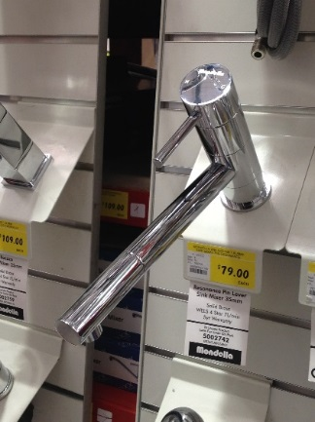
Kitchen / Bar / Laundry Sink Mixer

BATHROOM ACCESSORIES SELECTED – for 12 Bathrooms & 1 WC
- 11 x Toilets – Complete Ceramic toilet suite, Close Coupled, S Trap & Back to Wall (Bunnings Mondella or similar)
- 2 x Toilet Cisterns and toilet seats only (2 Existing Toilet pans to be reused)
- 12 x 600mm Towel Rail – Caroma Cosmo Metal Single Towel Rail 600mm or similar
- 1 x Hand Towel Rail – Caroma Cosmo Hand Towel Rail 200mm or similar
- 13 x Toilet Roll Holder – Caroma Cosmo Metal or similar
- 12 x Robe Hook – Caroma Cosmo Metal or similar
- 12 x Soap Dish – Metal Shelf with Soap Dish – or similar (Refer to shower photo below)
- 12 x Single Lever mixer tap ware for shower and Shower Arm & Rose on Adjustable Rod – or similar (Refer to shower photo below)
- 9 x 1320 wide Shower Screens with swinging door (FP1400)
- 2 x 1120 wide Shower Screens with swinging door (FP1200)
- 12 x Mirror – 750mm x 900mm wide Flat Edge Mirror
- 10 x Vanity – 600mm Rectangular Basin Vanity Unit ceramic top on feet – or similar (Refer to photo) (1 existing vanity & it’s tap spout to be reused)
- 1 x Basin Tap Handles for existing vanity – Raymor ETON or similar (refer to photo below)
- 12 x Single Lever mixer tap for basin (per Bunning Style below or similar)
- 13 x 40mm plug and waste for basin
- Mini Stops for basin & toilet
- 12 x 80 x 50 floor waste for shower
- 14 x Circular Light / Fan unit – Bunnings stock (Refer to photo below)
- 2 x Wall Mounted Basin for Disabled & WC (must had flat section at back to place soap bottle – similar to photo below)
- 2 x Disabled toilet / shower metal grab rails
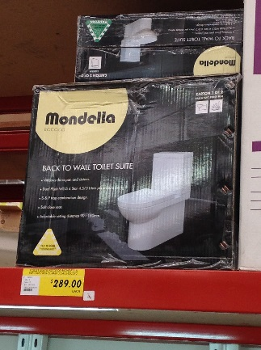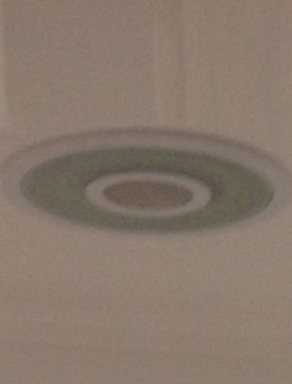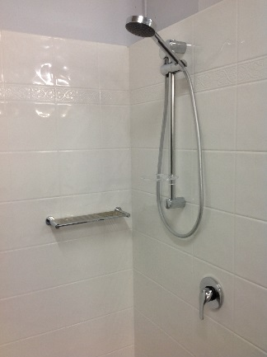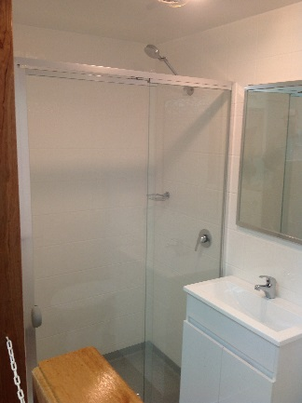
Close Coupled Toilet Fan / Light Unit Shower Accessories Shower Screen or similar
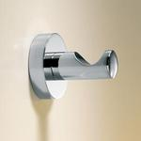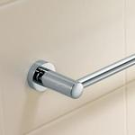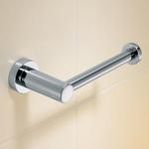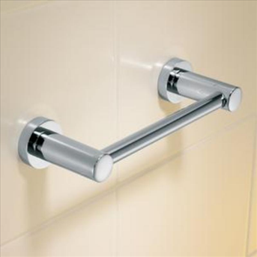
Caroma Cosmo Metal Accessories
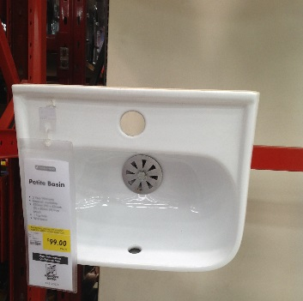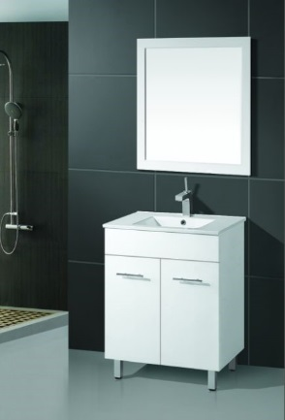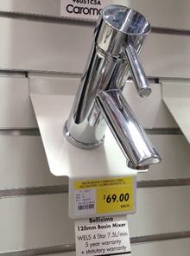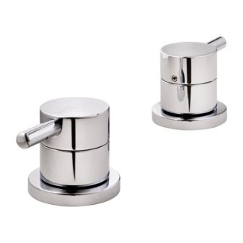
Ceramic Wall Basin Ceramic Top Vanity Basin Mixer New Basin Handles for Existing Vanity

